**Westfield High School**

## 

SHAM-ROCK-BOTICS is creating a tight-knit community of passionate problem solvers that will graduate from high school ready to take on the world! We do this through hands-on training, community outreach, and intense competitions.

**Would you be willing to support our team?**

**Community**

The reach of this program far outstretches the students and mentors that will fill the roster. The reach extends into the school as students recruit their friends and classmates. The reach extends further into the community as the team organizes demonstrations of their robot. The reach extends beyond that to the business centers as the team makes connections and builds partnerships. A FIRST team isn’t just the 30 names on a roster but the hundreds of people supporting them along the way.

**Passion**

This team is so much more than students learning from mentors how to twist a wrench and build a robot. This team was started by no less than 6 veteran mentors, 5 of which are alumni of the FIRST program, which shows this team is built on a foundation of passion for the FIRST program. A FIRST team is a wildly vast endeavor; from designing a robot - to designing a logo, from reaching for a game piece - to reaching into the community. Our goal is to give students with all manner of passions the opportunity to hone their craft, learning from the sharpest minds around.

**Fun**

The only things people truly commit to are things that bring them joy, that bring them satisfaction, the things that they find FUN! The ultimate motivator, FUN is a reward that can drive a team through all manner of challenging situations.

We know that if we can create a community of friends, who are all chasing their collective passions, they will have fun along the way. We know that if our students graduate from our program having fun solving big, tough problems, then they will be ready to take on anything that comes their way.

This is how we will build the next generation of problem solvers.

## 

SHAM-ROCK-BOTICS is building the next generation of problem solvers through:

* **Hands-On Learning:** 
  + Starting in January, students have six weeks to design, build, and program a 5ft tall, 120 lb robot before competition. Over the “build season” students are hands-on as they learn about trade offs (speed vs. weight), how to CAD parts for the robot, basic tool and machining use, problem-solving, sensor uses, wiring, pneumatics, and programming.

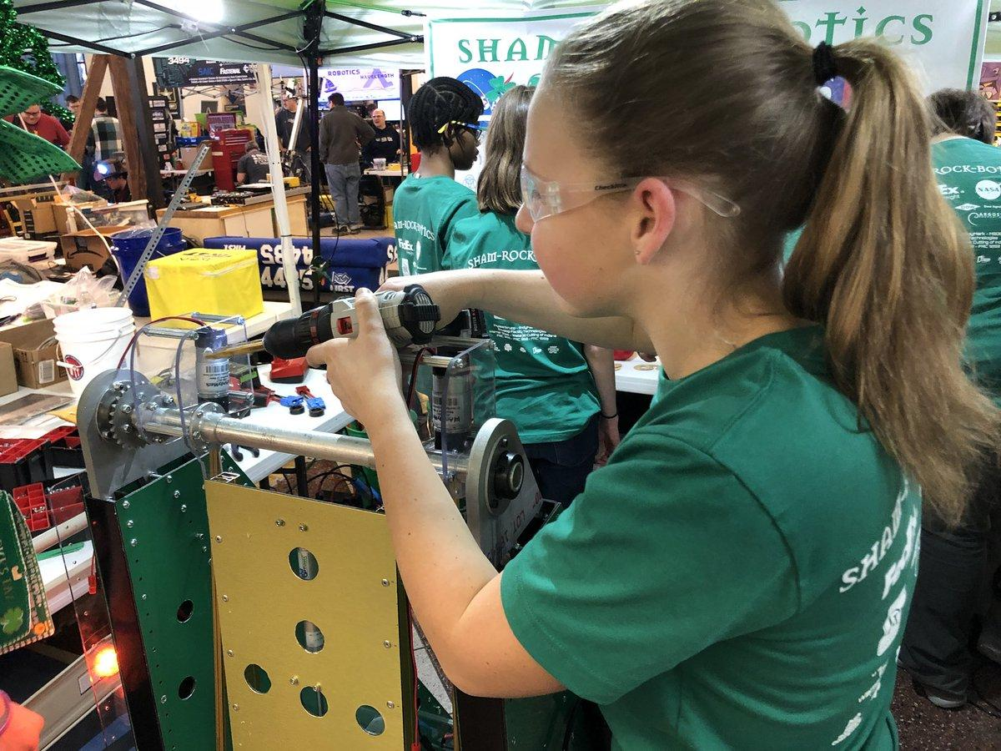 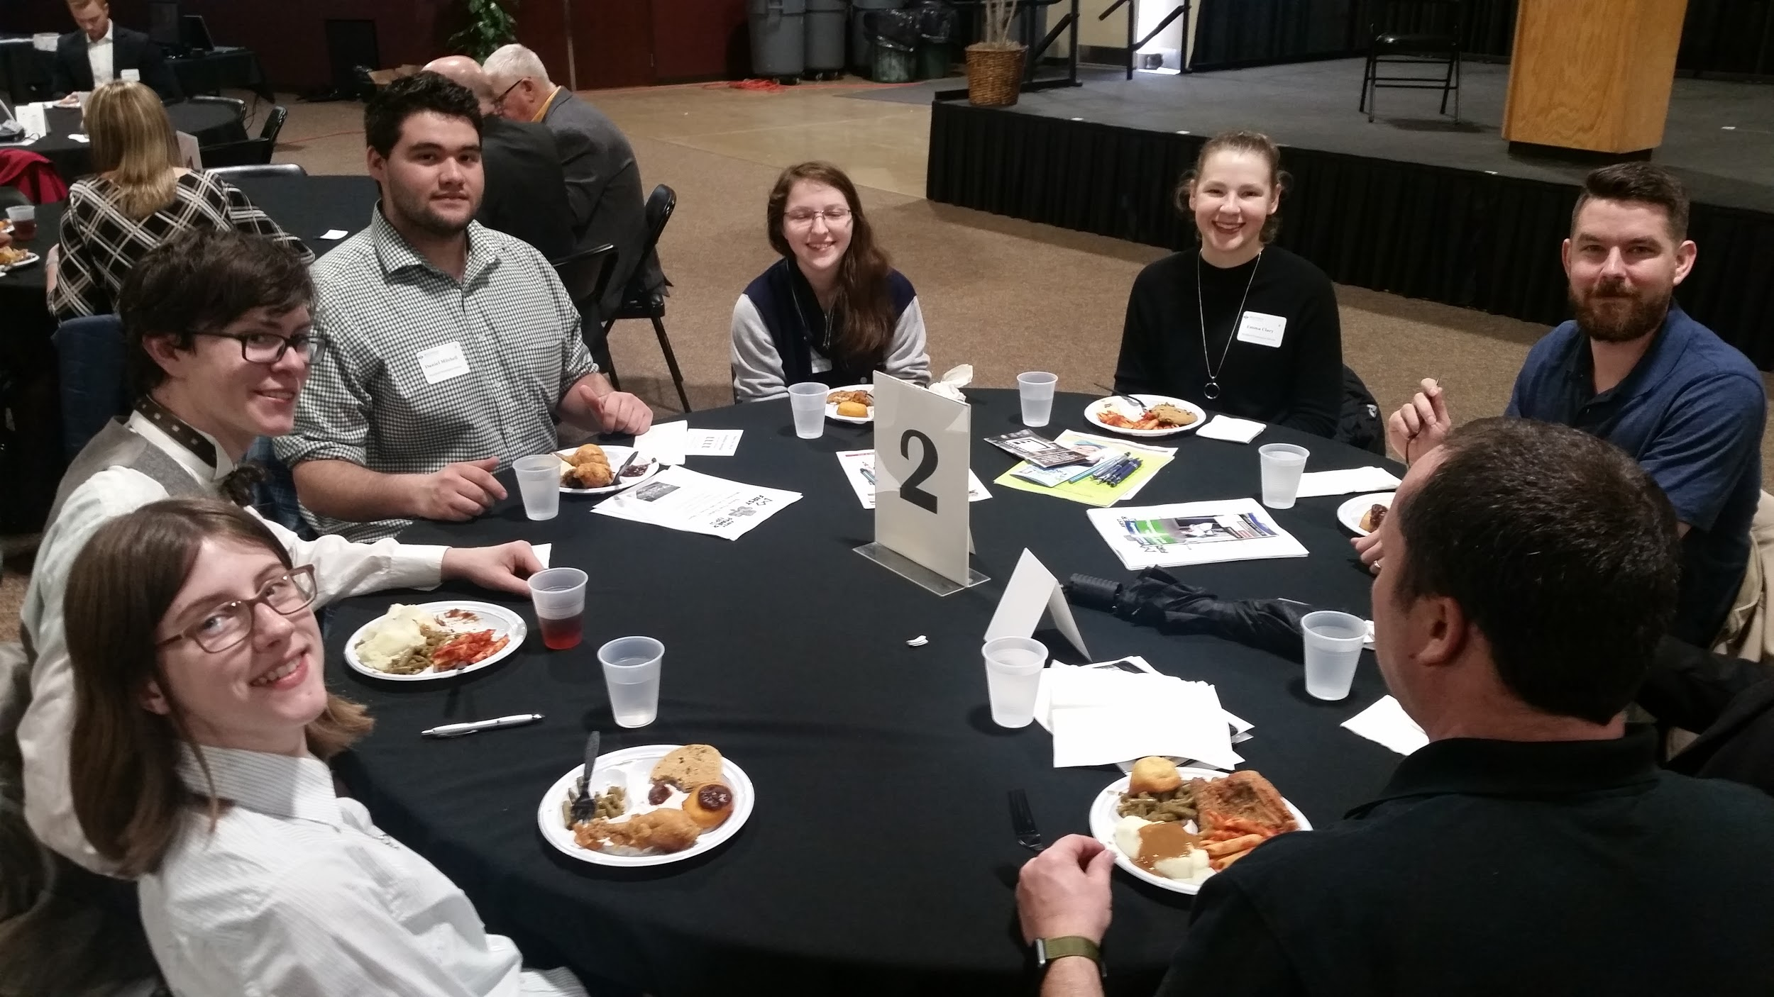 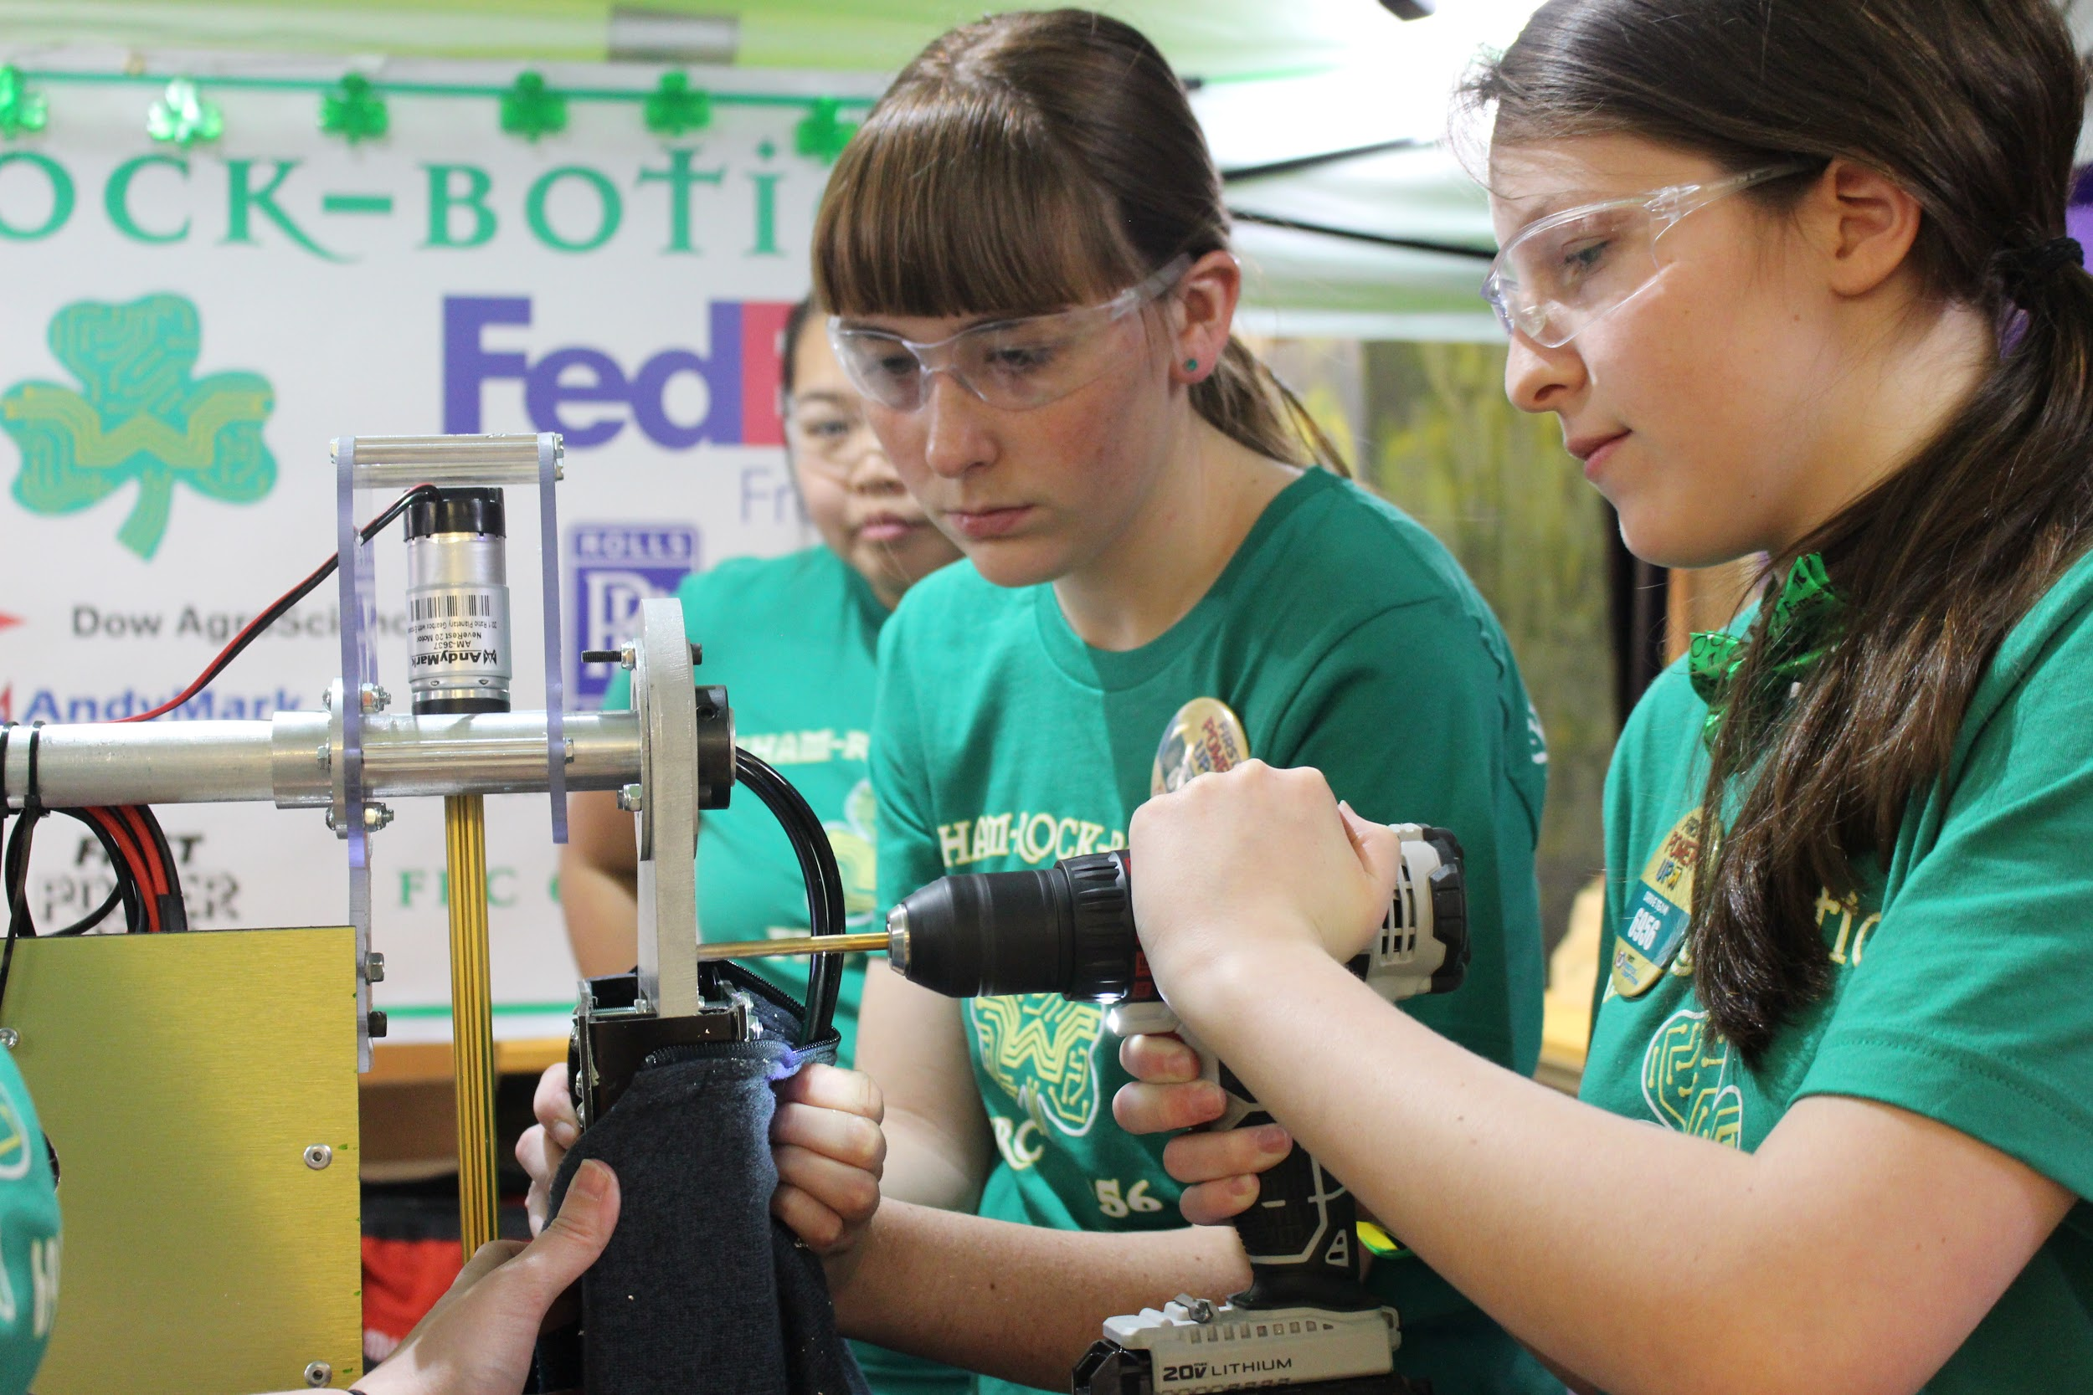

* **Intense Competition** 
  + At competitions the students have a short turnaround time between matches meaning they have to solve problems on the fly, make decisions about what should be fixed now vs. later, and learn to manage their adrenaline during those intense times. During a match, the team joins an alliance with two partners to compete head-to-head, 3 vs. 3, over a 2 minutes & 30 seconds period. Students learn to work as a team to score as many points as possible, developing valuable communication, teamwork, and leadership skills in the process.

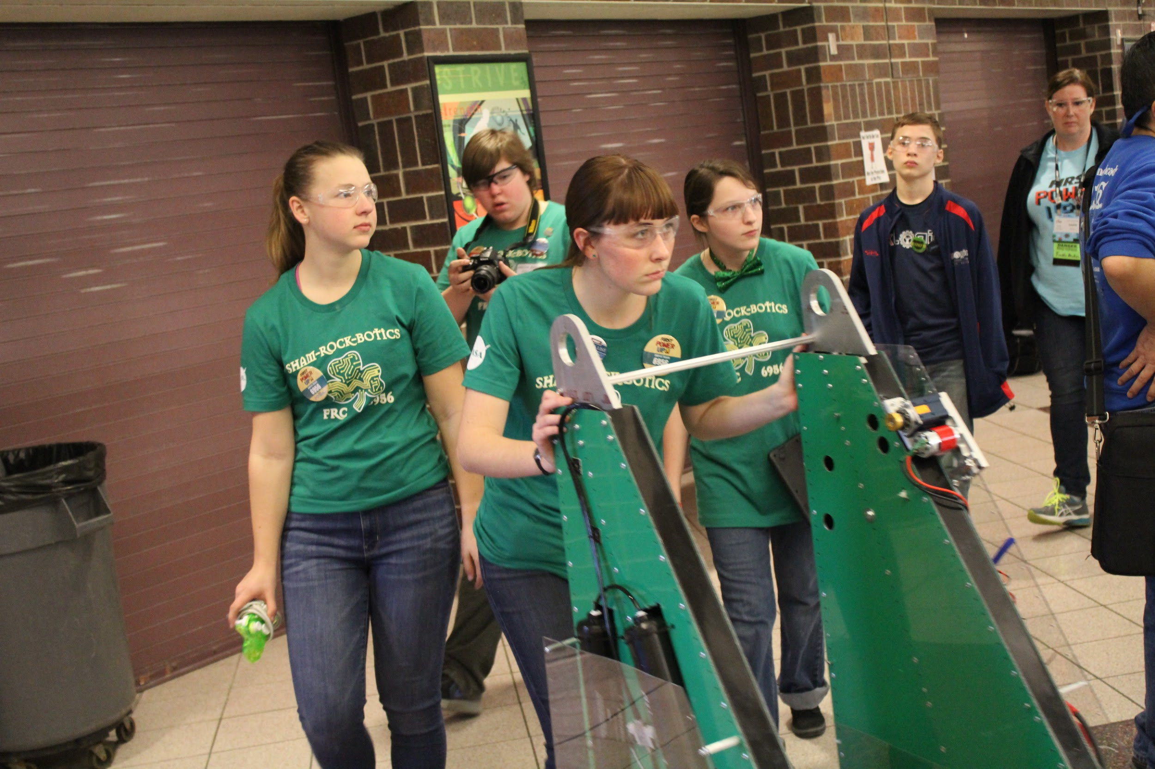 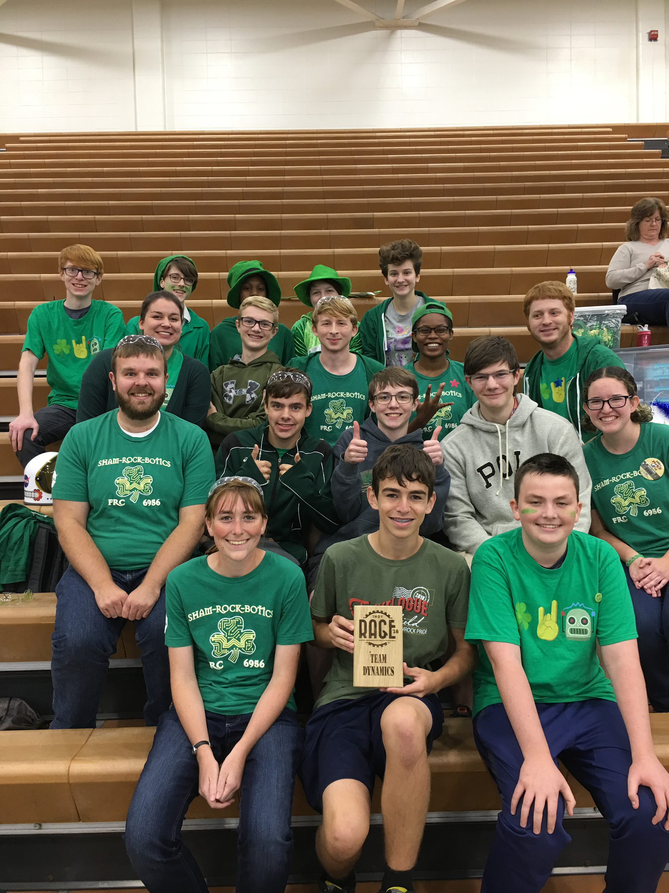 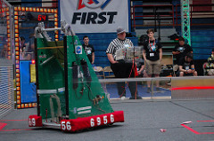

* **Mentorship**
  + Working side-by-side professional engineers, business professionals, and teachers, students are able to see how their experiences on an FRC team translates to a future career in engineering, programming, business, teaching, and many other professional career paths.

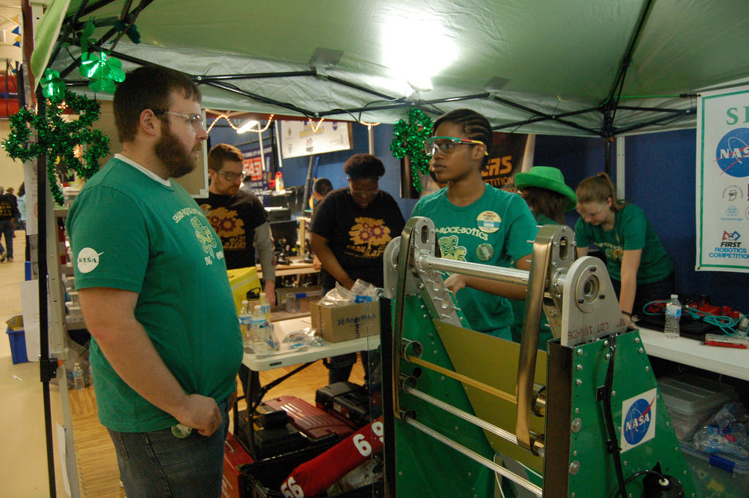 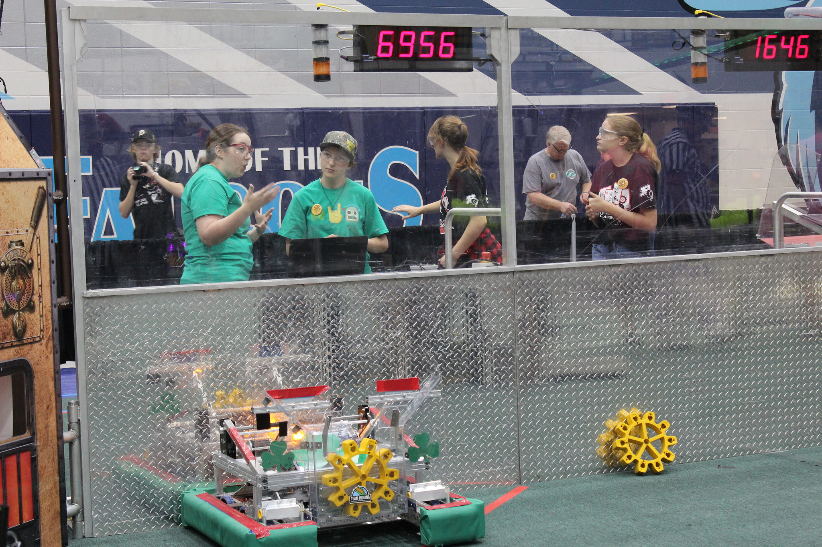 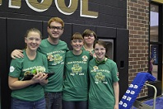

## 

There are many costs associated with running a FIRST team. Below is a list of specific items the team is fundraising for, in addition to the general costs associated with running the team.

|  |  |  |  |
| --- | --- | --- | --- |
| **Items & Description** | **# Needed** | **Single-Item Cost** | **Final Cost** |
| Saturday Lunches | 25 | $250 | $6,250 |
| Tool Chests/Small Organizers | 3/10 | $200/$30 | $600/$300 |
| Tools (Wrenches, Sockets, Pliers, etc.) | Many | $10 - $150 | ~$2,000 |
| Batteries & Charging Stations | 2 (9 Batteries) | $45 (Bat.)/$194 | $405/$388 |
| Power Tools (Drills, Saws, Sanders, etc.) | Many | $50 - $250 | ~$1,500 |
| Building Material (Wood, Aluminum, etc.) | Many | $100 - $500 | $2,000 |
| Laptops | 2-3 | $700 - $800 | $1,400 - $2,400 |
| DSLR Camera & Video Camera | 2 | $1,000 | $2,000 |
| Fasteners (Rivets, Velcro, Nuts, Bolts, etc.) | Many | $50 - $200 | $500 |
| Team T-Shirts | 45 | $12 | $540 |

Beyond material costs the team is also in need of mentors that could help in the following areas.

|  |  |
| --- | --- |
| **Mentor Needs** | **Role Description** |
| Graphic Design & Branding | Assisting students with creating an appearance and brand for the team |
| Fundraising Management | Assisting with fundraising, securing sponsorships & creating a business plan |
| Communication & Documentation | Working with students to submit documentation and essays for awards, grants, press releases and other needs |
| Programming | Helping students learn to program robot software, and website design. |
| Systems | Helping students learn about electronics and pneumatics |
| Mechanical | Working with students to build the robot and be safe in the workshop |

**SHAM-ROCK-BOTICS**

**Levels of Sponsor Support**

|  |  |
| --- | --- |
| **Sponsorship Amount** | **Recognition** |
| **$5,000+** | **Pot of Gold** (8 Available)   * Tournaments: Your company announced during each competition attended. * Tournaments: Invited to attend the official events as a VIP in an immersive experience. * Robot: Pot of Gold size logo of business added to the robot. * Banner: Pot of Gold size logo (displayed at events and tournaments) * **Team Shirts: Pot of Gold size logo on back of shirts (worn at events and tournaments)** * Website: Logo & link on sponsorship page and logo on home page * Memorabilia: Thank you letter and SHAM-ROCK-BOTICS shirt * Invitation to end of year banquet |
| **$3,000 - $4,999** | **Diamond Clover**   * Tournaments: Invited to attend the official events as a VIP in an immersive experience. * Robot: Diamond size logo of business added to the robot. * Banner: Diamond size logo (displayed at events and tournaments) * **Team Shirts: Diamond size logo on back of shirts (worn at events and tournaments)** * Website: Logo & link on sponsorship page and logo on home page * Memorabilia: Thank you letter and SHAM-ROCK-BOTICS shirt * Invitation to end of year banquet |
| **$1,000 - $2,999** | **Emerald Clover**   * Tournaments: Invited to attend the official events as a VIP in an immersive experience. * Robot: Emerald size logo of business, if space on the robot. * Banner: Emerald size logo (displayed at events and tournaments) * **Team Shirts: Emerald size logo on back of shirts (worn at events and tournaments)** * Website: Logo & link on sponsorship page and logo on home page * Memorabilia: Thank you letter and SHAM-ROCK-BOTICS shirt * Invitation to end of year banquet |
| **$500 - $999** | **Silver Clover**   * Tournaments: Invited to attend the official events for an immersive experience. * **Robot: Name of business, if space on the robot.** * Banner: Silver size logo (displayed at events and tournaments) * **Team Shirts: Name of business on back of shirts (worn at events and tournaments)** * Website: Logo & link on sponsorship page and logo on home page * Memorabilia: Thank you letter and SHAM-ROCK-BOTICS shirt * Invitation to end of year banquet |
| **$250 - $499** | **Bronze Clover**   * Tournaments: Invited to attend the official events for an immersive experience. * Banner: Name of business (displayed at events and tournaments) * Website: Logo & link on sponsorship page and logo on home page * Memorabilia: Thank you letter from the team. * Invitation to end of year banquet |
| **$25 - $249** | **SHAM-ROCK-BOTICS Supporter**   * Tournaments: Invited to attend the official events for an immersive experience. * Memorabilia: Thank you letter from the team. * Invitation to end of year banquet. |

## 

**Sponsorship Information**

Westfield High School

18250 North Union Street

Westfield, IN 46074

Michael Marley - marleym@wws.k12.in.us

Business Name: ______________________________________________________________

Contact Person: ______________________________________________________________

Address: ____________________________________________________________________

City: _______________________ State: ________________ Zip Code: __________________

Phone: (________) ___________________ Email: ___________________________________

Business Website: _____________________________________________________________

(Please print or type so that we can accurately include your information)

Please make checks payable to: Westfield High School, please write “Robotics” in the memo. When we receive the donation we will pass along a thank you letter. Give checks to your student contact, or mail to:

Westfield High School

Attn: Michael Marley, FRC Robotics Team

18250 North Union Street

Westfield, IN 46074

**Thank you for your support!**

Student Contact: _________________________________________________________

Amount Donated: $_____________ Check #________Cash_________

Material Donation: ________________________________________________________

**Your generosity is truly appreciated and will help build the next generation of problem solvers!**